Scenario
There is an application gateway, running from layer 2 - layer 7 in OSI model.
Here is the feature list
1. Switching, VLAN
2. Routing: static routing, dynamic routing with protocol supported: RIPv2, OSPF
3. Network services: DHCP, PORT Forwarding, Virtual server.
4. Firewall: MAC filtering, Packet filtering, Content filtering
5. Wi-Fi: support 802.11/a/b/g/n, with WEP, WPA, and WPA2
6. Support real-time streaming protocol
7. Management: support syslog, remote syslog, and upgrade firmware.
The product management support webpage and command line interface via ssh.

Please design test environment for: Functional testing to test feature Switching, VLAN

Answer:
Step 1: Understand the Switching and VLAN
Step 2: Base on the knowledge about Switching and VLAN, design all cases and make network diagram
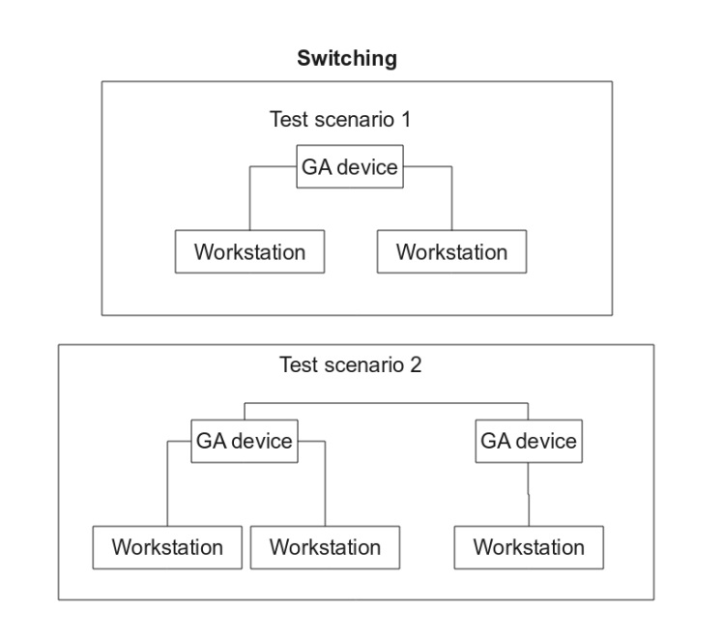
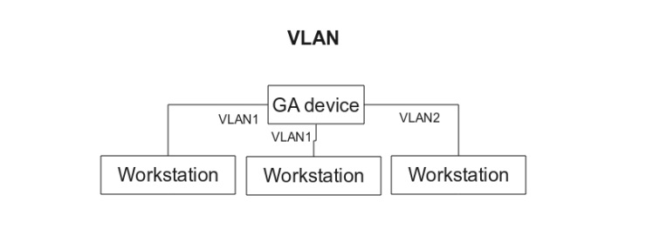
Step 3: Base on the diagram, note the quantity of devices (hardware) and what software necessary for testing
Test level | Feature to be tested | Hardware/software needed
Functional Testing | Switching and VLAN | - Hardware  - Router: 2  - Workstation: 3

Step 4: Base on the knowledge, diagram, software, hardware ... for testing, what/who/when... will training/share experience/user guide for test team

Type of Tool/Process | Tool /Process
Capture packet | Wireshark 1.99.9

Step 5: Specified what team/who will managing/setup/support the Test Environment.
Task | Role | Responsibilities
Test Environment Setup & Maintenance | IS Support  QA Manager | Plan, setup and maintain test environment with input from users
Test Environment Setup & Maintenance | IS Support | Help to setup test environment

Step 6: Complete the information in the the document

